Now accepting rental applications
Income Restricted/Affordable Rental Opportunities
Countryside Village | 450-460 Boston Post Rd. E, Marlborough, MA 01752
Maximum Rents
Type | Income | Rent
1-Bedroom | 50% AMI | $1,607
2-Bedroom | 50% AMI | $1,928
3-Bedroom | 50% AMI | $2,228
1-Bedroom | 60% AMI | $1,929
2-Bedroom | 60% AMI | $2,314
3-Bedroom | 60% AMI | $2,674
1-Bedroom | 80% AMI | $2,572
2-Bedroom | 80% AMI | $3,086
3-Bedroom | 80% AMI | $3,566

Gross Rents and Maximum Income Limits based on 2026 HUD Limits. Subject to change in 2027.
HH Size | 50% AMI | 60% AMI | 80% AMI
1 person | $60,000 | $72,000 | $96,000
2 persons | $68,600 | $82,320 | $109,760
3 persons | $77,150 | $92,580 | $123,440
4 persons | $85,700 | $102,840 | $137,120
5 persons | $92,600 | $111,120 | $148,160
6 persons | $99,450 | $119,340 | $159,120
7 persons | $106,300 | $127,560 | $170,080
8 persons | $113,150 | $135,780 | $181,040

To request an application by mail, please call 508-481-8032 or send an email to: countryside@trinitymanagementcompany.com
Completed applications can be mailed, emailed, or dropped off in person to
450-460 Boston Post Rd. E, Marlborough, MA 01752

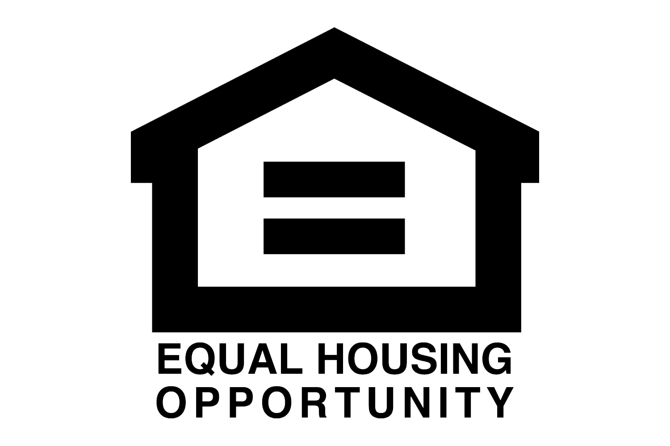

Use and Occupancy Restrictions Apply: Priority for accessible or adaptable apartments shall be given to persons requiring such features, including single person households, in conformity with state and federal civil rights laws. For more information or to request reasonable accommodation for persons with disabilities, please call Countryside Village - 508-481-8032

